**Ideation Phase**

**Brainstorm&Idea Prioritization Template**

|  |  |
| --- | --- |
| Date | 17 September 2022 |
| Team ID | PNT2022TMID33098 |
| Project Name | Project – Real Time River Water Quality Monitoring System |
| Maximum Marks | 4 Marks |

***Brainstorm & Idea Prioritization:***

**Step-1: Team Gathering, Collaboration and Select the Problem Statement**

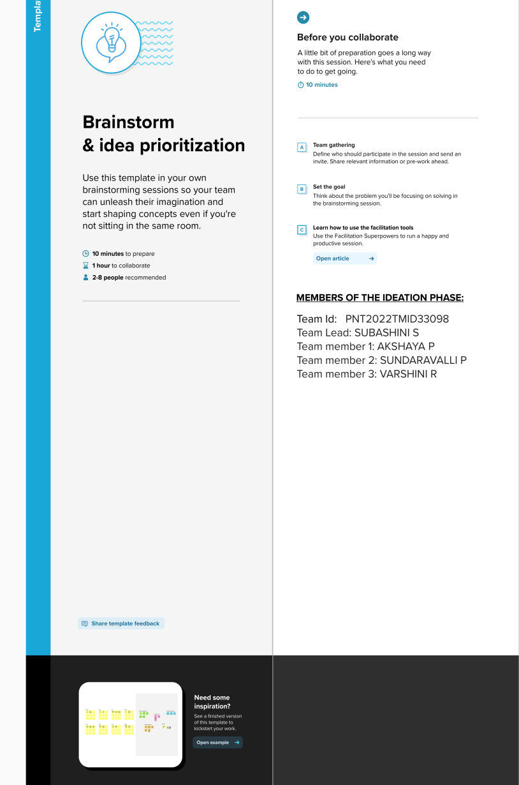

**Step-2: Brainstorm, Idea Listing and Grouping**

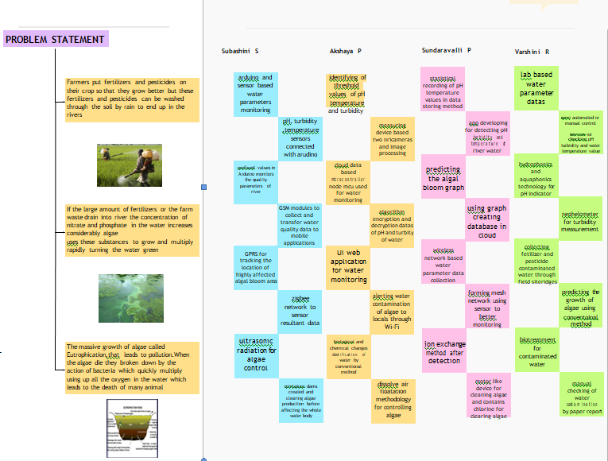

**Step-3: Idea Prioritization**

